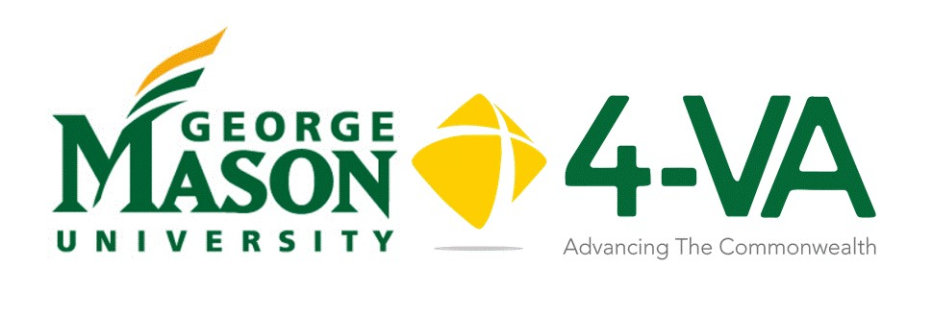
Complementary Funding
Request Form
Mason faculty involved in proposals with other 4-VA institutions will be eligible to apply for complementary funding to support cross university collaborative work. Up to $5,000 may be available in complementary funding for you as a Co-PI to a partner 4-VA institution. Grants are per school, not per researcher. Please note that 4-VA funds cannot be transferred between institutions.
Title of Project: ____________________________________________________________
Proposal Summary: (100 words max) _______________________________________________________________________________________________________________________________________________________________________________________________________________________________________________________________
Role | Name | University
Principal Investigator
Participant
Participant
Please identify which school(s) you are working with and the amount of funding at host institution as well as partner institutions:
Institution | Amount
George Mason University
James Madison University
Old Dominion University
University of Virginia
Virginia Commonwealth Univ
Virginia Military Institute
Virginia Tech
William and Mary

Project Timeline:
When do you expect to begin your project? ______________
By what date do you need your funding? ____________
What is the anticipated finish date? ______________

In order to process your grant request promptly, we need the following information regarding the person(s) responsible in your unit and college for your financial reconciliation. This is the person who will disburse your funds. Please provide their name and email address. There may be more than one person responsible.

Financial Officer:
Name: ________________________________________________________________________
Email: _________________________________________________________________________

I, along with those individuals listed above, have submitted the proposal to the host institution for grant funding. We request the amount indicated above as monetary support from 4-VA@Mason
Signature Date:

4-VA@Mason will send copy to Principal Investigator’s Institution.

Please recognize, if awarded the grant, funding recipients will need to comply with policies and procedures outlined in our MOU.

