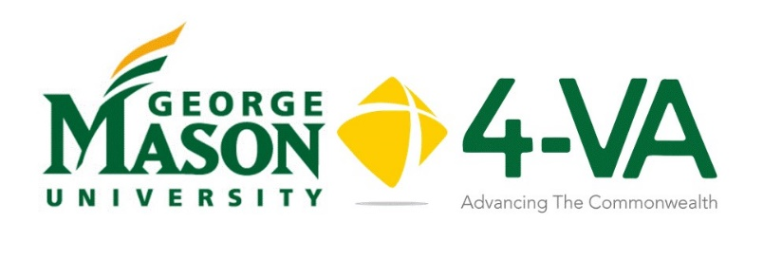

4-VA at Mason Collaborative Research Grants (CRG) 2020-2021

The 4-VA Collaborative is a partnership program that includes George Mason University, James Madison University, Old Dominion University, University of Virginia, Virginia Commonwealth University, Virginia Military Institute, Virginia Tech, and William and Mary. The 4-VA mission is to promote inter-university collaborations that leverage the strengths of each partner institution in order to accomplish more than any individual school could achieve alone.

The 4-VA at Mason Collaborative Research Grants are designed to improve research competitiveness within the Commonwealth and at Mason by providing funding for faculty to engage in pilot research focused on 4-VA goal areas that could be used as a springboard for subsequent, major federal grants. Collaboration with a researcher at one of the 4-VA partner institutions is strongly desired, as is active dissemination of the research findings. Projects that extend to at least one of the other 4-VA institutions will be given funding priority.

Funding amounts are expected to range from $5,000 to $20,000 per grant, not including complementary funding that may be supplied by partner institutions. NOTE: OSCAR will directly receive any funds designated for undergraduate researchers.

Who May Apply?
- Grants are available to full-time faculty or administrative faculty;
- Faculty who have received previous 4-VA grants may be eligible for additional funds, but preference will be given to new research projects.

Please review the following form carefully and complete each section with as much detail as possible. You may attach additional information as you see fit.

Proposal Title:
Lead PI:
Funding Requested:

Approval Signatures (Required)

Your Dean and Chair must review your grant proposal before submitting the request. Please provide requested information and obtain their signatures.
Dean
First Name

Last Name

Email

Signature:

Chair
First Name

Last Name

Email

Signature:

Proposal Title
Lead Pi Name/Job Title
Email Address
College and Department
Co Pi’s, Titles, Emails

Objective of CRG:

Please provide a project summary. (No more than 300 words.)

Anticipated Start Date of Project: _________________
Anticipated Project Completion: _________________

Anticipated number of paid faculty or staff working on the project: | Anticipated number of volunteer faculty or staff working on the project:
Anticipated number of paid undergraduate students on the project: | Anticipated number of volunteer undergraduate students on the project:
Anticipated number of paid graduate students on the project: | Anticipated number of volunteer graduate students on the project:
Please list participants and their role in the grant, including researchers from other institutions.
Name Role Paid? /Volunteer? Institution/Organization

Please list other institutions/organizations/companies with which you plan to collaborate:

Do you anticipate a colleague at a partner university will be applying for a Complementary Grant at their institution? Please delineate the researcher’s name and expected amount of funding.

Name: | School: | Amount:
Name: | School: | Amount:
Name: | School: | Amount:
Name: | School: | Amount:

Project Lifecycle: Please outline the anticipated stages/schedule for your project
Activity Timetable Expected Outcomes

How does your proposed research meet the goals of 4-VA? Please identify what 4-VA initiatives are being addressed.

What will your measures or indicators for success be with this project?

Active dissemination is expected to be a major project component. To be competitive for funding, projects should have a defined dissemination plan.

Publication/Presentation Date

Should your project receive positive outcomes, do you anticipate applying for further funding through an outside agency/foundation? If so, delineate which organizations:

Grant Process Timeline:

- The primary investigator (PI) submits a grant proposal March 1 – March 15, 2020
- Submitted proposals are reviewed by the Mason 4-VA Advisory Board.
- The 4-VA Campus Coordinator (Associate Provost, Janette Muir) finalizes grant approvals.
- Grantees are notified of outcomes April 15, 2020
- Funds for approved grants are released to the grantee(s) and grant work is permitted to commence July 1, 2020.
- Grantees comply with reporting and accountability requirements throughout the duration of the grant, as stipulated in the Memorandum of Understanding.
- All funding should be expended by June 30, 2021.

BUDGET

Please provide budget and budget justification that clearly describes the funding needed. Please be specific in your funding requests:
Name/Explanation Amount Semester
Faculty Stipends
Graduate Student Stipends
Undergraduate Research (OSCAR)
Materials (list)
Travel (list)
Other (list)
TOTAL

Budget Team for College / School / Unit:
If you are awarded Collaborative Research Grant, your funds will be allocated to a newly created budget ORG. To create this ORG, please provide the contact information for the officials in your unit that will be responsible for all financial transactions related to this grant (the items listed in the budget above). Please provide the following information to expedite creation of the ORG code should you be awarded a grant.

Name:
Title:
Email:
Mail Stop:

Name:
Title:
Email:
Mail Stop:

Name:
Title:
Email:
Mail Stop:

Name:
Title:
Email:
Mail Stop:

Name:
Title:
Email:
Mail Stop:

Name:
Title:
Email:
Mail Stop:

Name:
Title:
Email:
Mail Stop:

Name:
Title:
Email:
Mail Stop:

