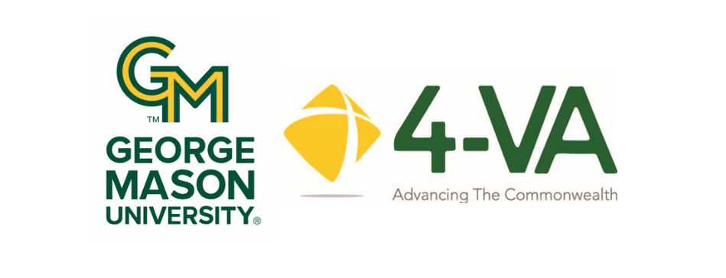

4-VA@Mason Collaborative Research Grant (CRG)
Application for Funding AY 2026-2027

4-VA@Mason Collaborative Research Grants are designed to promote inter-university collaborations that leverage the strengths of each institution to improve education and research outcomes. 4-VA provides small scale funding -- ranging from $5,000 to $20,000 -- for faculty to engage in pilot research that could be used as a springboard for subsequent external grants.

Other members of the collaborative are Christopher Newport University, the College of William and Mary, James Madison University, Old Dominion University, Radford University, the University of Virginia, Virginia Military Institute, and Virginia Tech. These partner institutions may support Co-PI research with complementary funding from their campus 4-VA office.

4-VA@Mason Collaborative Research Grant proposals are evaluated for the following:
- Presents clear rationale for pilot/novel investigation
- Identifies potential solutions for education, technology, human health, environment/science, or workforce readiness
- Incorporates collaborations or future collaborations with:
- Other 4-VA schools
- Virginia-based individuals and organizations
- Provides opportunities for student experiential research
- Justifies appropriate personnel assigned to the project and budget
- Includes detailed research objectives and timeline to achieve successful results
- Contains plans for dissemination of research findings
- Includes detailed budget which reflect George Mason University and state fiscal policies
- Identifies possible potential expansion of project via external funding sources

Who may apply as a PI?
- Grants are available to full-time faculty or administrative faculty. Adjunct faculty may participate, but the lead PI must hold a full-time position.
- Faculty previously receiving 4-VA funding may apply for subsequent grants, however, preference will be given to those who have not received a prior 4-VA@Mason award.

Grant Process Timeline:

- Applications accepted on a rolling basis until: February 14, 2026, 5:00 PM EST.
- Submitted applications reviewed by the 4-VA@Mason Advisory Board.
- Grantees notified of awards: April/May 2026.
- Funds for approved grants released to the grantee and research is permitted to commence: July 2026.
- All funding should be expended by early June 2027, in order to clear encumbrances through the system

Review the application carefully and complete pages 2-5 with as much detail as possible. This application should be strictly followed. Additional support documentation may be submitted (Section J).

Grantees must comply with reporting and accountability requirements throughout the duration of the grant, as stipulated in the Responsibilities of Lead PI, page 6.

- Proposal ID

Proposal Title:
Lead PI Name/Title:
Email Address:
College and Department:
Department “M” number:
Co-PIs at Mason:
Name/Title

B. Approval Signatures

Both the Dean and Chair of the Lead PI must review and approve the grant proposal before submission to
4-VA@Mason. (Electronic signatures are acceptable.)
Dean
Name: _____________________________________________
Signature: __________________________________________
Chair
Name: _____________________________________________
Signature: __________________________________________

- Executive Summary. Rationale for pilot/novel research: (200 words maximum)

C 1. Has similar work in this area been undertaken by the collaborators in the past? ________
C 2. If yes, please describe the differences:

- Outline solutions for education, technology, human health, environment/science, or workforce
readiness for Virginia to be addressed by research:

E. Collaboration with 4-VA Schools
List collaborators at other 4-VA partner institutions. If the proposal includes collaborations at more than
two 4-VA institutions, copy and paste the following fields as necessary. There may be Complementary Grants
available at other 4-VA schools. Contact Faculty and Community Outreach Coordinator Elizabeth Gillooly
with questions about Complementary funding in the state.
Note that partner school complementary funding is not guaranteed.

Partner School:
CO-PI Name/title/email address:
Role in project:
Anticipated request for Complementary Grant? Amount?
Will students at this institution be involved in the research? If so, how many?

Partner School:
CO-PI Name/title/email address:
Role in project:
Anticipated request for Complementary Grant? Amount?
Will students at this institution be involved in the research? If so, how many?

F. Other external partners/organizations/consultants. Note if Virginia based.

G. George Mason University research participants

Faculty/Staff:
Name(s) Volunteer/Paid Role

Undergraduate Students:
Name(s) if known. Volunteer/Paid Role

Graduate students:
Name(s) if known. Volunteer/Paid Role

- Research Timetable and Objectives
Outline the anticipated schedule for your project:
Anticipated Start Date of Project: _________________
Anticipated Completion Date: _________________

Calendar Dates Objective/Activity

G. Planned Dissemination
Publication/Presentation/Other Distribution Outlets

H. Continued Research
Should your project receive positive outcomes, do you anticipate seeking further funding through an
external agency/foundation? If so, outline potential organizations for future funding:

I. 4-VA@Mason Budget
Please coordinate with your department financial officer to develop a budget and justification for funding.
This is for funding from 4-VA@Mason only; do not include budget for collaborators.
Budget |  |  |  | Subtotal
 | Name(s) | Academic Year | Summer Term
Faculty Stipends |  | $ | $
Fringe Rates* |  | $ | $
Administrative Faculty |  | $ | $
Fringe Rates* |  | $ | $
Classified Staff |  | $ | $
Fringe Rates* |  | $ | $
Adjuncts, Special Pay, Summer Faculty, and Wages |  | $ | $
Fringe Rates* |  | $ | $
Graduate Student |  | $ | $
Fringe Rates* |  | $ | $
Undergraduate Student |  | $ | $
Fringe Rates* |  | $ | $
Supplies - detail
Contractual Services - detail
Travel - detail
TOTAL

Fringe rates listed below are based on the current rates. Use these percentages as a placeholder, however, they may change slightly for the 26-27 AY.

FT Faculty 31.40%
PT Faculty 7.40%
Admin Faculty 31.40%
Classified 39.60%
GRA 0%
College Work Study 4.20%
Wage 7.40%

Note: Full-time student wage employees are exempt if they are enrolled in classes. If they are not taking classes over the summer, but will be paid for work on a project, fringe should be calculated.

Department Financial POC: Name: ______________________________________ email: ______________________

J. Please attach any additional materials appropriate to support the planned research.

Responsibilities of the Lead PI
The grant recipient is the responsible financial party.

4-VA@Mason Expenditure Process, Policies, and Schedule
4-VA research funds are governed by the Commonwealth of Virginia financial policies and procedures. All 4-VA@Mason grant expenditures must be spent and/or reimbursed in accordance with the Mason Financial Procedures Manual and university policies. For more information, visit fiscal.gmu.edu.
Upon receiving a grant award, a new budget ORG is created, into which the grant funding is disbursed. This ORG code will reside within the unit and will be monitored by the unit’s financial team. Any questions regarding utilization of funds should be directed to the unit’s budget and financial team prior to any expenditures or encumbrances.
It is imperative that grant activities and expenditures match the awarded proposal. If there are changes, a modified budget must be submitted to the 4-VA@Mason office and approved in advance.
All funds within the ORG should be dispensed completely before the grant deadline in early June 2027, to assure that any encumbrances are cleared through the system.
4-VA Promotion, Acknowledgements, and Assessments
Promotion
4-VA@Mason staff will promote research projects via a variety of outlets:
- Website: https://4va.gmu.edu/
- Newsletter: Aperture.
- Social media/publications/presentations throughout the University.

Acknowledgements
Grantees are asked to acknowledge 4-VA support in any written, digital, or oral presentations and/or references using the following language:
This research was funded by 4-VA, a collaborative partnership for advancing higher education and research in the Commonwealth of Virginia. OR:
This research was funded in part by 4-VA, a collaborative partnership for advancing higher education and research in the Commonwealth of Virginia.

Grantees are asked to incorporate the 4-VA at Mason logo in any printed, digital, or published documentation. Download the 4-VA@Mason logo.
Assessments
4-VA@Mason expects grant recipients to respond to activity assessments – a Mid-Project Report and a Final Project Report, and an activity questionnaire after the completion of the project (for up to five years). These assessments are vital for 4-VA reporting and compliance.

Failure to fulfill the above will result in the loss of funding and ineligibility for future grants through 4-VA.
I agree to the 4-VA@Mason policies and procedures:
Signature: __________________________________________________

