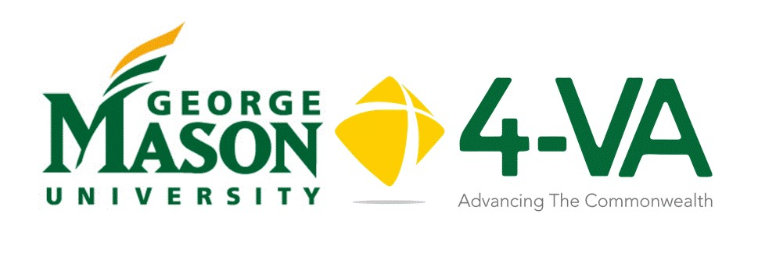
Complementary Funding
Request Form
Mason faculty involved in proposals with other 4-VA institutions may be eligible to apply for complementary funding to support cross university collaborative work. Up to $5,000 may be available in complementary funding for Mason’s participation in the research. Grants are per school, not per researcher. Please note that 4-VA funds cannot be transferred between institutions.
Title of Project: _______________________________________________________________________
Proposal Summary: (100 words max) _______________________________________________________________________________________________________________________________________________________________________________________________________________________________________________________________
Role | Name | University
Principal Investigator
Mason CO-PI Participant
Please identify which school(s) are involved in the research project and the amount of funding provided at host institution as well as partner institutions:
Institution | Amount
George Mason University
James Madison University
Old Dominion University
University of Virginia
Virginia Commonwealth Univ
Virginia Military Institute
Virginia Tech
William and Mary

Project Timeline:
When do you expect to begin your project? ______________
By what date do you need your funding? ____________
What is the anticipated finish date? ______________

Expenses: Personnel/Supplies/Other (Please Detail)

Purpose Requested

To process your grant request promptly, provide the following information regarding the person(s) responsible in your unit and college for your financial reconciliation. This is the person who will disburse your funds. Please provide their name and email address. There may be more than one person responsible.
Financial Officer:
Name: ________________________________________________________________________
Email: _________________________________________________________________________
Financial Officer:
Name: ________________________________________________________________________
Email: _________________________________________________________________________

Applicant:
Name: (Print) ________________________________________ Email:________________________
Signature________________________________________ Date: ________________________

School: _________________________________________ Department: _______________________

4-VA@Mason will notify Principal Investigator’s Institution.

All funding recipients must comply with Mason and Virginia state policies and procedures.

