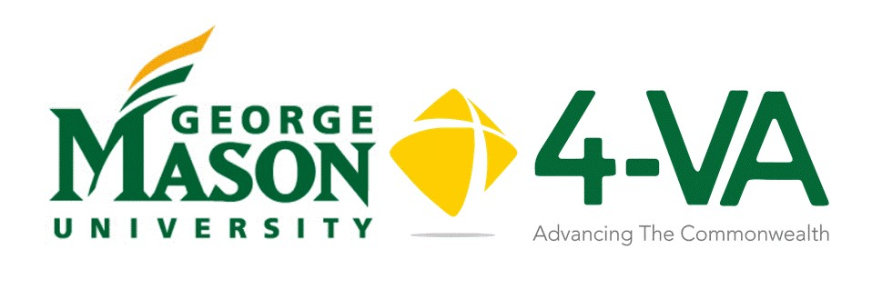
Complementary Funding 24-25
Request Form
Mason faculty involved in proposals with other 4-VA institutions may be eligible for up to $5,000 in complementary funding to support cross university collaborative work. Grants are per school, not per researcher. This 4-VA@Mason application should be submitted after the Lead PI has signed and returned the letter of agreement with the lead institution. All funding recipients must comply with Mason and Virginia state policies and procedures. Visit fiscal.gmu.edu.
Title of Project:
Lead PI Name/Title/email:

Mason CO-PI Name/Title/email:
School and Department:
Department # M:
Project Objective/Executive Summary: (100 words max)
Mason’s role in the project:
Will Mason students (undergrad and/or grad) (paid or volunteer) participate in the project?
Project Timeline
When do you expect to begin your project?
What is the anticipated finish date?

To process your grant request promptly, provide the following information regarding the person(s) responsible in your unit and college for your financial reconciliation. (There may be more than one person responsible.)
Financial Officer:
Name:
Email:
Financial Officer:
Name:
Email:

Budget |  |  |  | Subtotal
 | Summer Term | Academic Year
Faculty Stipends
Fringe Rates*
Administrative Faculty
Fringe Rates*
Classified Staff
Fringe Rates*
Adjuncts, Special Pay, Summer Faculty, and Wages
Fringe Rates*
Graduate Student
Undergraduate Student
Fringe Rates*
 |  |  | Detail
Supplies - detail
Contractual Services - detail
Travel - detail
TOTAL

*Fringe Benefit Rates
Current Fringe Benefit Rates for 23-24. These rates may change slightly for the 24-25 AY. Use these rates as a placeholder:
- Instructional, Research Administrative Faculty — 30.70%
- Classified Staff — 39.50%
- Adjuncts, Special Pay, Summer Faculty, and Wages — 7.2%
- GTAs and GRAs — 0%
- Student Wage — 6.8%
Note: Full-time student wage employees are exempt from the FICA tax.
4-VA funds cannot be transferred between institutions.

